Lesson – Clothes vs Fashion

Monday: Do clothes really matter in the Bible?
From the first fig leaf loincloth in Genesis 3:7 to the last washed robes in Revelation 22:14, clothing has been central to the redemption of mankind. We will study various accounts of clothing and fashion in the Bible, beginning with the origin of clothing next week, but before that, we are going to start at an even more rudimentary level: God’s sovereignty over all things and His use of them in His Plan of Salvation.

Read: 2 Timothy 3:14-17.
You, however, continue in the things you have learned and become convinced of, knowing from whom you have learned them, and that from childhood you have known the sacred writings which are able to give you the wisdom that leads to salvation through faith which is in Christ Jesus. All Scripture is inspired by God and beneficial for teaching, for rebuke, for correction, for training in righteousness; so that the man or woman of God may be fully capable, equipped for every good work.

Read: Romans 11:36.
For from Him, and through Him, and to Him are all things. To Him be the glory forever. Amen.

Consider: What is the purpose of Scripture? What is the purpose of all created things?

Definitions
Clothing and fashion are not interchangeable words, but they both permeate the Bible.
Clothing refers to shirts, pants, and any kind of covering that you wear on your body.
Fashion is a social construct that arises from our conventions, traditions, and reactions to not only our clothing but our hairstyle, makeup, piercings, posture, and any other way you present yourself to other people.
Clothing or Fashion? Circle your answer!
Sackcloth and ashes (Jonah 3) | Clothing or Fashion?
The robe of many colors (Genesis 37:3) | Clothing or Fashion?
The Holy Place dress code for Aaron and his sons (Exodus 28) | Clothing or Fashion?
The armor of God (Ephesians 6:10-20) | Clothing or Fashion?
Paul’s respectable apparel for women (2 Timothy 2) | Clothing or Fashion?

Tuesday: Why do clothes exist?
Clothes at the most basic possible level are physical objects.
Consider: What is the purpose of physical objects? Why are physical objects so prominent in Scripture, especially the cross?
Read: Romans 1:20.
For since the creation of the world His invisible attributes, that is, His eternal power and divine nature, have been clearly perceived, being understood by what has been made, so that they are without excuse.
Consider: What things make you think of spiritual things or remind you of a Bible verse? Alternatively, is there a particular physical motif that stands out to you in Scripture?

Church father Irenaeus (130-202 A.D.) opens Book V, Chapter 29 of Against Heresies, saying,
I have set forth the causes for which God permitted these things to be made, and have pointed out that all such have been created for the benefit of that human nature which is saved, ripening for immortality that which is [possessed] of its own free will and its own power, and preparing and rendering it more adapted for eternal subjection to God. And therefore the creation is suited to [the wants of] man; for man was not made for its sake, but creation for the sake of man. Those nations however, who did not of themselves raise up their eyes unto heaven, nor returned thanks to their Maker, nor wished to behold the light of truth, but who were like blind mice concealed in the depths of ignorance, the word justly reckons as waste water from a sink, and as the turning-weight of a balance — in fact, as nothing; Isaiah 40:15

Wednesday: Speaking through fashion
You do not have to be a Christian to know clothes are already more than clothes. We turn them into fashion. Fashion is a social construct, so it’s not about physical garments but how we present ourselves in different social situations. I would even say fashion is a form of communication.
Read: 2 Kings 9:30
Read: 2 Samuel 15:30
The Bible shares two opposite accounts of a royal figure facing apparent imminent judgment. Jezebel whose sinful life needs no introduction, heard that Jehu slayed her son and has now arrived in town. Likewise, when rebel prince Absalom stole the throne and raised up an army. Surely both wondered if they were about to die for their sin. Not a word is spoken, but we can read the state of Jezebel and David’s hearts through the way they present themselves. This is fashion as a form of communication.

Consider: What moments come to mind when I say “fashion in the Bible.” What garment, outfit, or form of bodily self-expression really pops off the page?

Fashion can be a powerful form of communication, but I want to emphasize that fashion exists for us. It is how we share ourselves with other people. We can impress each other with our fancy words and fashion, but God sees straight through it like an x-ray.
Read: 1 Samuel 16:7
The context is God sending Samuel to anoint the next king of Israel, and all he knows right now is he will be a son of Jesse. The eldest may look downright princely to Samuel, but his heart is naked before the Lord.

So if we have the channel of fashion to communicate through, how are Christians called to use it? The Bible is clear we are to build each other up and direct people to the work of salvation. I know fashion is an incredibly abstract concept, so I don’t want you to think too hard about just how to do that through clothing, but I do want you to take every word you say with gravity.

Read: Matthew 12:36-37

Read: Ephesians 4:29-32
But we are called to greater things than pleasing people. We will be made beautiful forever if we share our gifts and lead others to God.
Read: Daniel 12:3
And those who have insight will shine like the glow of the expanse of heaven, and those who lead the many to righteousness, like the stars forever and ever.

Thursday
Our first thought of the week: God tailor-made the physical world to point to heavenly truth. This semester, we will look at how God uses clothing as a symbol, but apply this to your field of interest. If you are a numbers nerd, God absolutely speaks through numbers in the Bible. He speaks through colors, food, music, travel, sports, love and marriage...he even speaks through puppy dogs.
Our first challenge of the week is to let your natural interests point you to God’s invisible attributes as you read the Bible this week. I think our interests and hobbies are healthy and God-given, so lean into them in as Scriptural a way as you can.
Our second thought of the week: God gave us social communication so we can act as the body of Christ, do His work, and reach an unsaved world.
Our second challenge of the week: Express yourself as a follower of Christ and let your activities be an opportunity to share the gospel with the unsaved and encourage your friends in Christ.

Week 1 – The Origin of Clothes

Monday
We are reading about clothes to study God and His Plan of Redemption. They were right there at the beginning of the Bible as one of the first and most visceral symbols of redemption in the Bible (Genesis 3:7), and they are one of the last symbols of our righteousness (Revelation 22:14).
The Fall is one of the most discussed Bible passages ever, but read it again and try to relate to Adam and Eve. I want us to really hone in on the clothes here and how God is using them to illustrate His invisible qualities and our spiritual condition.
Read: Genesis 3
Discuss - Why did we not need clothes in our original state?
[We had no need for covering before God. No sin separated us from His presence in the Garden.]
Discuss – Let me ask another way. In verse 7, it says Adam and Eve saw their nakedness. What were they really seeing here, with their newly opened eyes?
[Spiritually, they knew good and evil. They saw their own evil. They were naked before God’s righteousness. Practically, they were entering a fallen world where they need the protection from the elements, work uniforms, etc.]
Discuss – Who made the first clothes, and what were they?
(https://toptropicals.com/catalog/uid/ficus_carica.htm)


(https://toptropicals.com/catalog/uid/ficus_carica.htm)
Discuss – What do you think they thinking when they started sewing clothes?
[They were hiding their sin. They were not seeking God’s power but acting on their own.]
Read: Job 31:33-34 -
Have I covered my wrongdoings like a man,
By hiding my guilt in my shirt pocket,
Because I feared the great multitude
And the contempt of families terrified me,
And I kept silent and did not go out of doors?
This is a temptation for sinners – to hide our sin then hide from others.
So fast-forward – God had them confess, then he cursed the Serpent, prophesied the coming of Christ as the seed of the woman, cursed her and Adam. Adam names his wife Eve. Then God makes a set of real clothes.
Read: Genesis 3:21
And the Lord God made garments of skin for Adam and his wife, and clothed them.
Discuss – Now this is a really heavy question. What was God demonstrating when he covered them in coats of skins?
[Maybe the skins came from an animal that was killed and skinned before their eyes. He demonstrated death. Paul said the wages of sin is death, and God literally shows it here. But this is not a senseless death – this is a sacrificial spilling of blood. Here is the Lamb slain from the foundation of the world. And God gave it to us to clothe us in His righteousness so He can no longer see our nakedness.]
Thought of the week: When you see your clothes, remember we’re clothed in righteousness, paid for by a blood price.
Challenge of the week is to be broken in spirit over our sin. The sensation of sin shocked Adam and Eve. The consequence of death wrapped around Adam and Eve. It’s still wrapped around us today, so be vigilant against sin.

Week 2 – King David, A Life told through Wardrobe Changes

David was a shepherd boy living in Bethlehem. Let’s look at some of the clothes worn in the Middle East around 1000 B.C.

Here’s some active Assyrian clothes from a similar time period to David (1000 B.C-ish), Reproduced from Ancient Egyptian, Assyrian, & Persian Costume by M. G. Houston & F. S. Hornblower, 1920)
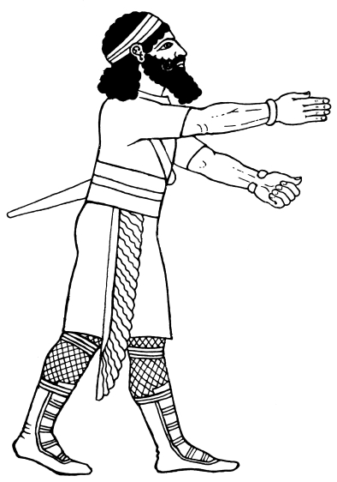This man, in hunting dress, ninth century B.C., has a small scarf, fringed only at the ends, wrapped tightly round the limbs, reaching to the knee.
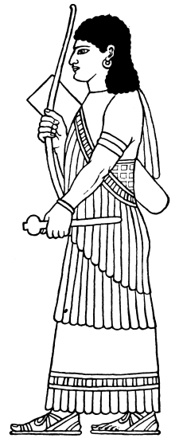The point to be noted in this figure is the arrangement of a fringe drapery which goes once round the waist, is thrown over one shoulder, and hangs down the back.
These are illustrations for theater costume, but they are created by referencing bas-reliefs (“bah relief”), statues, pottery, and other archaeological finds. The goal of ancient artists was probably to capture a historical or religious moment, not the reality of contemporary clothing, but this is the only surviving source for us to study. We have to guess how they wrapped around and placed seams.

Knit fabric wasn’t invented until well after Jesus’ death nor were stretchy fibers like spandex, so there’s no way clothing was as form-fitting as art makes it seem. Clothing was typically constructed from fabric squares and rectangles. Wool tunics were the dominant style.

Leather garments could be form-fitting, as they would be worn like a “second skin.”
The British Museum #118871 - https://www.britishmuseum.org/collection/object/W_1851-0902-507
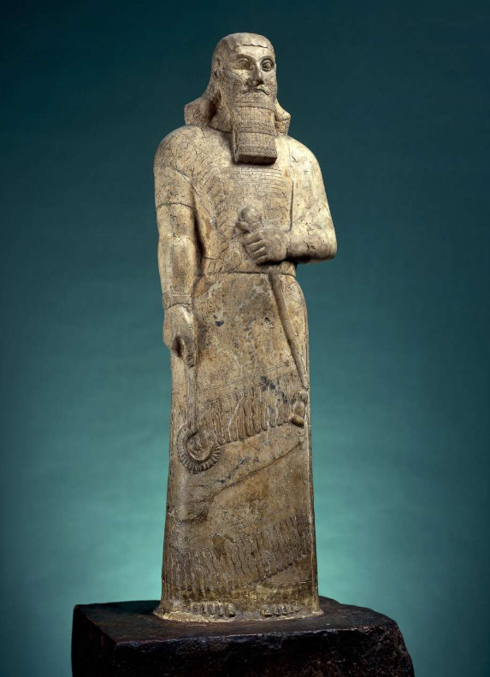Carved magnesite statue of Ashurnasirpal II (883-859 B.C. ) of Assyria on reddish dolomite stand: the king stands bare-headed, without the royal crown. His hair is long, but his long and magnificent curled beard is more imposing than that which a courtier would have worn. The king's dress consists of a short-sleeved tunic on top of which a long fringed shawl has been fastened, covering most of his body below the waist; the shawl is drawn over the left arm, round the back, and then forwards over the right shoulder, to be secured to the belt in front. In his right hand he carries a ceremonial sickle of a kind which gods sometimes use for fighting monsters; the mace in his left hand symbolises the authority vested in him as vice-regent of the supreme god. An inscription is carved on his chest.

(Retrieved from World History Encyclopedia @ https://www.worldhistory.org/image/15282/relief-from-medinet-habu-depicting-philistine-capt/)
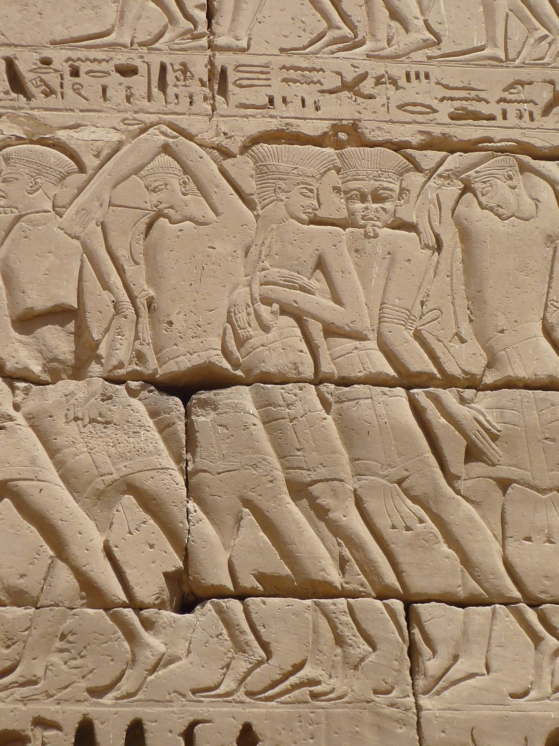A photo of a wall relief of Philistine captives being led away after their failed invasion of Egypt. Located at the mortuary temple of Ramses III (1186–1155 BC), Medinet Habu, Theban Necropolis, Egypt
A Neo-Hittite relief (10th century B.C.) taken from the British Museum @ https://www.britishmuseum.org/collection/object/W_C-153
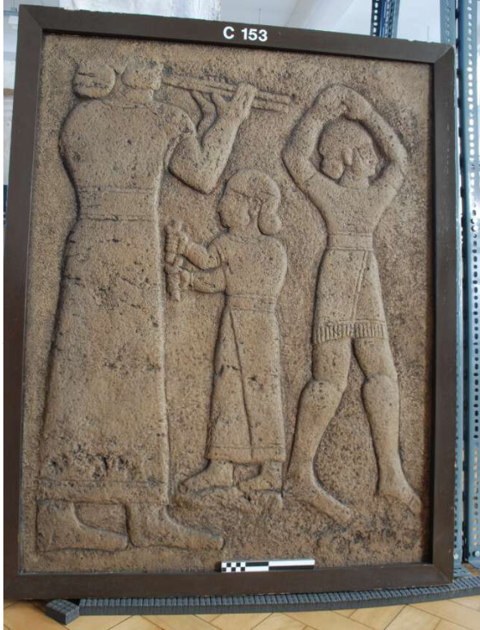Figure A: Plaster cast of a Neo-Hittite relief; large figure on left, walking right, wearing a long gown and playing double pipes; small central figure with pair of rattles; figure on fight wearing a short skirt or kilt and dancing with both hands clasped overhead; painted brown in imitation of original limestone; mounted in wooden frame; hairline crack in centre.

Week 3 – Jacob’s Disguise
Let’s open in prayer.
Pray:
To recap from last week, can anyone give me a definition of clothing in the context of our reading of Adam and Eve?
Recap: The definition of clothing.
Clothing is a physical reminder that we are clothed in righteousness, paid for by a blood price.

Intro

Week 4 – The Fashion of King David

Week Last – The fashion of Christ

